**CSCE 5400 Formal Languages, Automata, and Computability - Fall 2024**

**Name:** Kishan Kumar Zalavadia

**EUID:** 11685261

**Assignment-2**

1. Find an inductive definition for each set S. In this question, N is the set of Natural numbers

and includes 0. (4 points)

1. S: {1, 5, 13, 29, 61, …}

Or

1. S: {a2n | n ϵ N } U { a2n+1 | n ϵN }

2. Define a grammar for each of the following languages: (6 points)

a) L = {bb, bab, baab, baaab, ... }

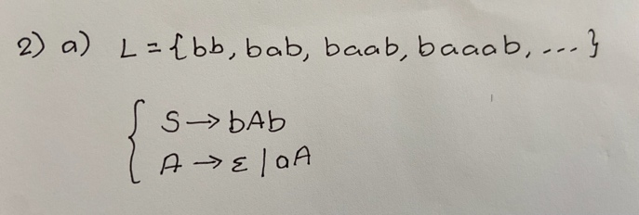

b) {𝑎𝑛|𝑛 ∈ 𝑁} ∪ {𝑏𝑐𝑛 | 𝑛 ∈ 𝑁} * N is the set of Natural numbers and includes

c) aa*cbb*d∑= {a,b,c,d}

🡨or 🡪

S 🡪 aS|acB

B 🡪 bB|bB

3. Construct an NFA for the following languages. (6 points)

i. (a + b)*a

ii. (ab + abc)*

4. **(A)** Convert the following NFA to equivalent DFA. (**B**) Show the steps for the conversion. (10 points)

Over alphabet {a , b}.

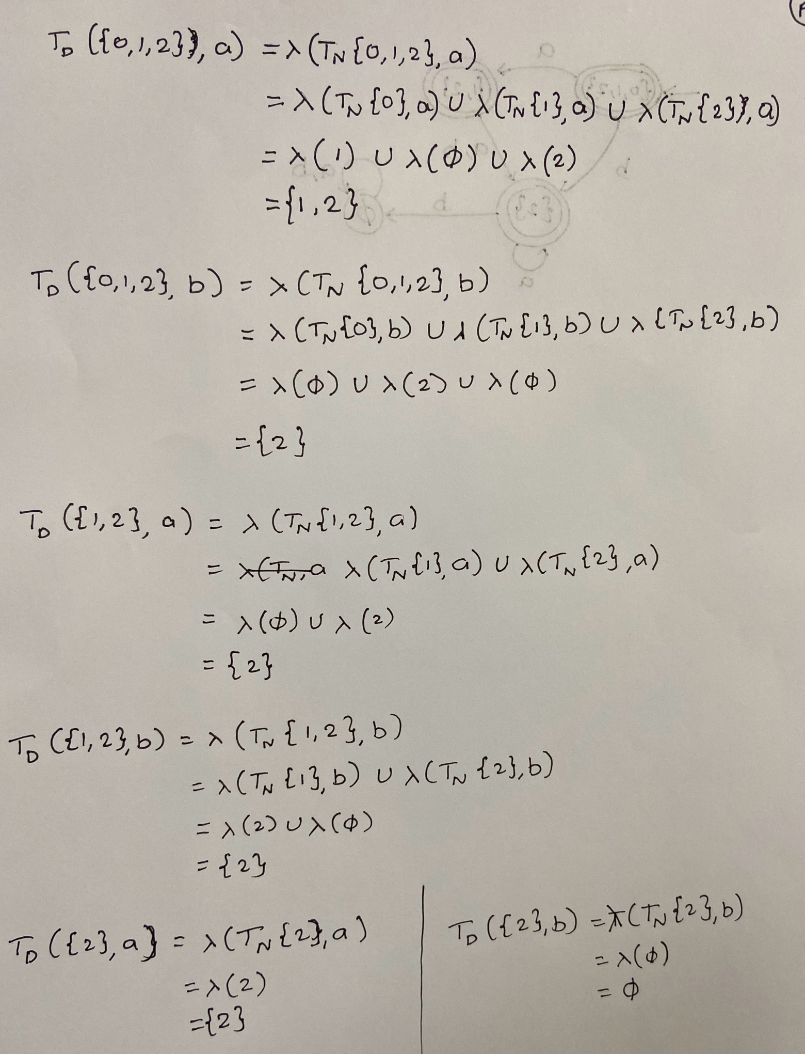

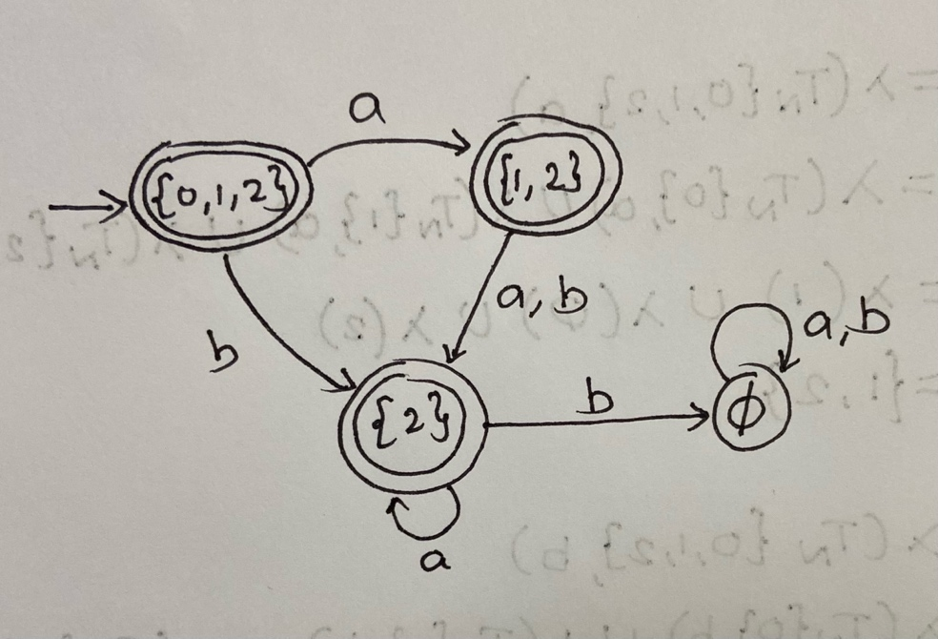

5. What is the NFA of the following regular grammar? (4 points)

S → abS | aS | ba

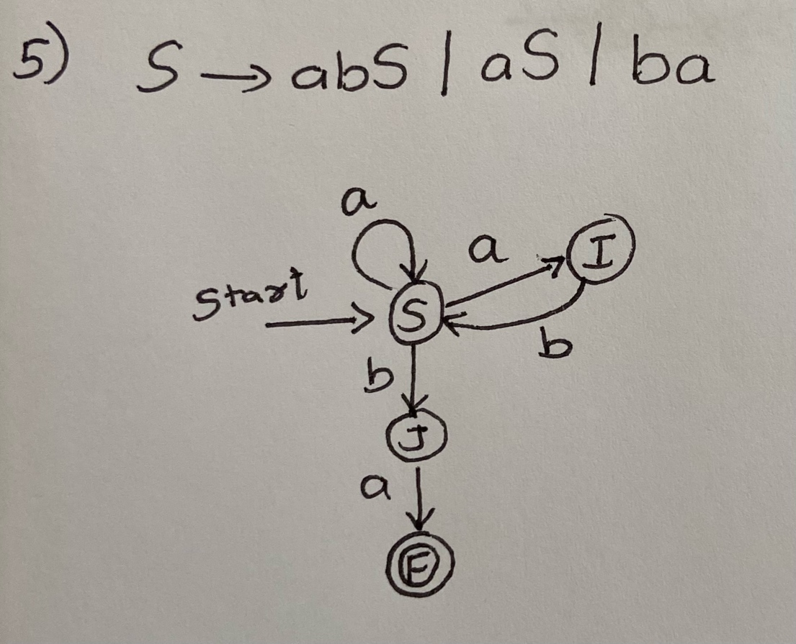

6. Convert the following NFA to an equivalent Regular Expression using **GNFA method**. Please first delete state B, then state S, and finally state A. (10 points)

